# PROJECT REPORT ON

**WEB-BASED QUIZ PLATFORM**

**Carried Out at**



# CENTRE FOR DEVELOPMENT OF ADVANCED COMPUTING ELECTRONIC CITY, BANGALORE.

**UNDER THE SUPERVISION OF**

**Ms. Archana T**

**[Project Associate] C-DAC Bangalore**

**Submitted By**

**Manaoj Pentapalli [240850120075]**

**Mudit Kumar [240850120079]**

**Sudhanshu Patel [240850120143]**

**Utkarsh [240850120153]**

**Vashu Choudhary [240850120157]**

# PG DIPLOMA IN ADVANCE COMPUTING

**C-DAC, BANGALORE**

***Candidate’s Declaration***

We hereby certify that the work being presented in the report entitled Smart Banking Solution, in the partial fulfillment of the requirements for the award of Post Graduate Diploma in Advance Computing and submitted in the department of DAC of the C-DAC Bangalore, is an authentic record of our work carried out during the period 6th Dec 2024 – 12th Feb 2025 under the supervision of Prof. Bhumika Narang, Project Associate, C-DAC Bangalore.

The matter presented in the report has not been submitted by me for the award of any degree of this or any other Institute/University.

**(Name and Signature of Candidate)**

**Manoj Pentapalli**

**Mudit Kumar**

**Sudhanshu Patel**

**Utkarsh**

**Vashu Choudhary**

**Counter Signed by**

**Ms. Archana T**

# APPROVAL CERTIFICATE

This Project report entitled "**Web Based Quiz Platform**" by **Manoj Pentapalli (240850120075**) is approved for post Graduate Diploma in Advance Computing (PG-DAC) of Centre for Development of Advanced Computing Electronic City, Bangalore.

Place: Bengaluru Date:

Examiner:

(Signature)

(Name)

# APPROVAL CERTIFICATE

This Project report entitled "**Web Based Quiz Platform**" by **Mudit Kumar (240850120079**) is approved for Post Graduate Diploma in Advance Computing (PG-DAC) of Centre for Development of Advanced Computing Electronic City, Bangalore.

Place: Bengaluru Date:

Examiner:

(Signature)

(Name)

# APPROVAL CERTIFICATE

This Project report entitled "**Web Based Quiz Platform**" by **Sudhanshu Patel (240850120143**) is approved for Post Graduate Diploma in Advance Computing (PG-DAC) of Centre for Development of Advanced Computing Electronic City, Bangalore.

Place: Bengaluru Date:

Examiner:

(Signature)

(Name)

# APPROVAL CERTIFICATE

This Project report entitled "**Web Based Quiz Platform**" by **Utkarsh (240850120153**) is approved for Post Graduate Diploma in Advance Computing (PG-DAC) of Centre for Development of Advanced Computing Electronic City, Bangalore.

Place: Bengaluru Date:

Examiner:

(Signature)

(Name)

# APPROVAL CERTIFICATE

This Project report entitled "**Web Based Quiz Platform**" by **Vashu Choudhary (240850120157**) is approved for Post Graduate Diploma in Advance Computing (PG-DAC) of Centre for Development of Advanced Computing Electronic City, Bangalore.

Place: Bengaluru Date:

Examiner:

(Signature)

(Name)

# CERTIFICATE

This is to certify that the project report entitled “**Web Based Quiz Platform**”, submitted by **Manoj Pentapalli** is the Bonafide work completed under our supervision and guidance in partial fulfillment for the award of Post Graduate Diploma in Advance Computing (PG-DAC) of Centre for Development of Advanced Computing Electronic City, Bangalore.

Place: Bangalore Date:

#### Ms. Archana T Prof. Bhumika Narang

Guide Course Coordinator

#### Dr. Mohammed Misbahuddin

Associate Director, CDAC-Bangalore

# CERTIFICATE

This is to certify that the project report entitled “**Web Based Quiz Platform**”, submitted by **Mudit Kumar** is the Bonafide work completed under our supervision and guidance in partial fulfillment for the award of Post Graduate Diploma in Advance Computing (PG-DAC) of Centre for Development of Advanced Computing Electronic City, Bangalore.

Place: Bangalore Date:

#### Ms. Archana T Prof. Bhumika Narang

Guide Course Coordinator

#### Dr. Mohammed Misbahuddin

Associate Director, CDAC-Bangalore

# CERTIFICATE

This is to certify that the project report entitled “**Web Based Quiz Platform**”, submitted by **Sudhanshu Patel** is the Bonafide work completed under our supervision and guidance in partial fulfillment for the award of Post Graduate Diploma in Advance Computing (PG-DAC) of Centre for Development of Advanced Computing Electronic City, Bangalore.

Place: Bangalore Date:

#### Ms. Archana T Prof. Bhumika Narang

Guide Course Coordinator

#### Dr. Mohammed Misbahuddin

Associate Director, CDAC-Bangalore

# CERTIFICATE

This is to certify that the project report entitled “**Web Based Quiz Platform**”, submitted by **Utkarsh** is the Bonafide work completed under our supervision and guidance in partial fulfillment for the award of Post Graduate Diploma in Advance Computing (PG-DAC) of Centre for Development of Advanced Computing Electronic City, Bangalore.

Place: Bangalore Date:

#### Ms. Archana T Prof. Bhumika Narang

#### Guide Course Coordinator

#### Dr. Mohammed Misbahuddin

Associate Director, CDAC-Bangalore

# CERTIFICATE

This is to certify that the project report entitled “**Web Based Quiz Platform**”, submitted by **Vashu Choudhary** is the Bonafide work completed under our supervision and guidance in partial fulfillment for the award of Post Graduate Diploma in Advance Computing (PG-DAC) of Centre for Development of Advanced Computing Electronic City, Bangalore.

Place: Bangalore Date:

#### Ms. Archana T Prof. Bhumika Narang

Guide Course Coordinator

#### Dr. Mohammed Misbahuddin

Associate Director, CDAC-Bangalore

# ACKNOWLEDGEMENT

We take this opportunity to express our gratitude to all those people who have been directly and indirectly with us during the competition of this project. We pay thanks to Prof. Bhumika Narang who has given guidance and light to us during this major project. We acknowledge here out debt to those who contributed significantly to one or more steps. We take full responsibility for any remaining sins of omission and commission.

##### Student Names:

Manoj Pentapalli [240850120075]

Mudit Kumar [240850120079]

Sudhanshu Patel [240850120143]

Utkarsh [240850120153]

Vashu Choudhary [240850120157]

**ABSTRACT**

The Web-Based Quiz Platform is an innovative online system designed to facilitate seamless quiz management for educators and engaging test-taking experiences for students. This platform enables administrators to efficiently create, manage, and upload quizzes using CSV files while allowing students to take timed tests with real-time scoring. A comprehensive leaderboard system ranks students based on their performance across multiple subjects.

This project follows a structured three-tier architecture with a React.js-based frontend, a Spring Boot-powered backend, and a MySQL database for efficient data storage and retrieval. Key features include user authentication, quiz attempt tracking, automated quiz submission, performance analytics, and leaderboard generation.

Future enhancements may include AI-driven question recommendations, multi-language support, and real-time cheating detection mechanisms.

This document provides an in-depth overview of the platform’s objectives, system design, implementation details, and potential improvements to create a robust and scalable online quiz management solution.

**TABLE OF CONTENTS**

|  |  |  |
| --- | --- | --- |
| **S. No** | **Section & Sub-Section** | **Page No.** |
| 1 | **Introduction** | **1-2** |
|  | • Purpose | 2 |
|  | • Background | 2 |
| 2 | **Project Objectives** | **3** |
| 3 | **Scope of the Project** | **4-7** |
|  | • Features for Educators | 4 |
|  | • Features for Students | 7 |
| 4 | **System Architecture** | **8-10** |
| 5 | **Functional Requirements** | **11-13** |
|  | • User Management | 11 |
|  | • Quiz Management | 11 |
|  | • Quiz Attempt and Scoring | 12 |
|  | • Reports & Leaderboard | 13 |
| 6 | **Database Design** | **14** |
| 7 | **Technology Stack** | **14** |
| 8 | **Implementation Details** | **15** |
| 9 | **Testing & Security Considerations** | **16** |
| 10 | **Conclusion & Future Enhancements** | **16** |
|  | • Summary | **16** |
|  | • Future Enhancement | **16** |

**LIST OF FIGURES**

|  |  |  |
| --- | --- | --- |
| **Fig.no** | **Figure Name** | **Page no** |
| 3.1 | Admin Dashboard | 4 |
| 3.2 | User Dashboard | 5 |
| 3.3 | Quize Page | 6 |
| 3.4 | Score Board | 6 |
| 3.5 | Leader Board | 7 |
| 4.1 | System Architecture Digram | 10 |

**ABBREVIATIONS & ACRONYMS**

|  |  |
| --- | --- |
| **Acronym** | **Full Form** |
| API | Application Programming Interface |
| CSV | Comma-Separated Values |
| DBMS | Database Management System |
| HTTPS | Hypertext Transfer Protocol Secure |
| JWT | JSON Web Token |
| MySQL | My Structured Query Language |
| RBAC | Role-Based Access Control |
| REST | Representational State Transfer |
| UI | User Interface |
| CRUD | Create, Read, Update, Delete |
| IDE | Integrated Development Environment |
| SDK | Software Development Kit |

**Chapter 1**

## **INTRODUCTION**

The **Web-Based Quiz Platform** is an advanced online system designed to facilitate seamless quiz management and assessments in educational institutions, corporate training environments, and self-learning scenarios. The platform empowers educators to create and manage quizzes efficiently while enabling students to take tests with real-time scoring and analytics. With an intuitive interface, automated quiz submission, and leaderboard rankings, this platform enhances engagement and knowledge retention for learners. In the digital age, traditional paper-based quizzes and exams are being replaced with online assessments due to their efficiency, accessibility, and scalability. Manual quiz evaluation is time-consuming and prone to errors, making automation essential. This platform addresses these challenges by providing a streamlined solution for quiz creation, automated scoring, and insightful performance analytics.

The platform offers numerous benefits, including accessibility, as users can participate in quizzes from anywhere using a web browser. Automated evaluation and real-time feedback reduce the administrative burden, making the system highly efficient. It also supports scalability, ensuring a large number of users can access the platform without performance degradation. Security is a key focus, with data protection mechanisms such as encrypted authentication and access control. Additionally, customization options allow educators to create quizzes with varying formats, difficulty levels, and timed assessments.

This Web-Based Quiz Platform is designed for educational institutions such as schools, colleges, and universities that seek to conduct assessments digitally. It is also beneficial for corporate training programs aimed at evaluating employees' skills and knowledge. Students preparing for competitive exams and certifications can utilize the platform to practice, while EdTech companies can integrate the quiz system into their e-learning solutions to enhance user engagement.

The primary objectives of the platform include providing a user-friendly interface for creating and managing quizzes, enabling secure authentication for students and administrators, supporting CSV-based quiz uploads for bulk question management, implementing real-time scoring and leaderboard ranking for performance tracking, and ensuring a scalable database architecture for storing structured quiz data.

## **1.1 Purpose**

The purpose of this project is to develop a **Web-Based Quiz Platform** that serves as a comprehensive solution for online assessments. The platform is designed to allow educators to seamlessly create, manage, and conduct quizzes while enabling students to participate in an interactive and user-friendly environment. By providing a structured approach to quiz management, this system enhances the learning experience through real-time evaluation, automated grading, and performance tracking. Educators can upload questions in bulk using **CSV files**, set quiz durations, and categorize questions based on difficulty levels or subject matter. The platform also incorporates a **leaderboard system**, offering students insights into their performance and fostering a competitive learning environment.

## **1.2 Background**

Traditional paper-based quizzes and assessments present several challenges, including manual evaluation, delayed results, and logistical difficulties in managing a large number of students. The **Web-Based Quiz Platform** is designed to overcome these limitations by automating the entire process of quiz administration. With its **database-driven architecture**, the platform efficiently handles structured data, such as user profiles, quiz questions, student responses, and scoring records. **MySQL** has been chosen as the database management system due to its reliability, scalability, and ability to perform complex queries efficiently.

This platform aims to bridge the gap between conventional learning methodologies and modern educational technology by offering **secure authentication mechanisms**, ensuring **data integrity**, and providing **detailed analytics** for educators to track student performance. The system supports **multiple-choice questions, timed quizzes, and auto-submission features**, making it adaptable to various assessment needs. Additionally, with **real-time result processing and progress tracking**, both students and educators can derive meaningful insights that help improve learning outcomes.

By integrating advanced quiz management functionalities with a structured backend architecture, the **Web-Based Quiz Platform** sets a benchmark for digital assessments, offering efficiency, accessibility, and enhanced engagement for both educators and students.

**Chapter 2**

## **PROJECT OBJECTIVE**

* **Provide a user-friendly interface for quiz management.**

The platform is designed with an intuitive and responsive user interface, ensuring a seamless experience for educators and students. With a structured layout and easy navigation, users can efficiently create, manage, and attempt quizzes without technical difficulties.

* **Enable secure authentication for admins and students.**

Security is a priority in the system, ensuring that only authorized users have access. The platform implements robust authentication mechanisms, including **role-based access control (RBAC)**.

* **Support bulk quiz uploads using CSV files.**

To simplify quiz creation, the system allows administrators to upload multiple quiz questions at once using **CSV file imports**. This feature streamlines content management, reduces manual effort, and supports quick quiz deployment for educators.

* **Implement real-time quiz scoring and leaderboards.**

The platform ensures that students receive immediate feedback on their quiz performance through **real-time score calculation**. Additionally, a **leaderboard system** ranks students based on their performance across various subjects, fostering a competitive and engaging learning environment.

* **Ensure data integrity and security.**

The system is built with **MySQL as the database backend**, ensuring structured and reliable data storage. Security measures such as **data encryption, secure API endpoints, and regular database backups** are in place to prevent data loss and unauthorized modifications, maintaining the integrity of student scores and quiz records.

**Chapter 3**

## **SCOPE OF THE PROJECT**

## **3.1 Features for Educators**

* Create quizzes.
* Upload questions in **CSV format**.
* Set **quiz duration and difficulty levels**.

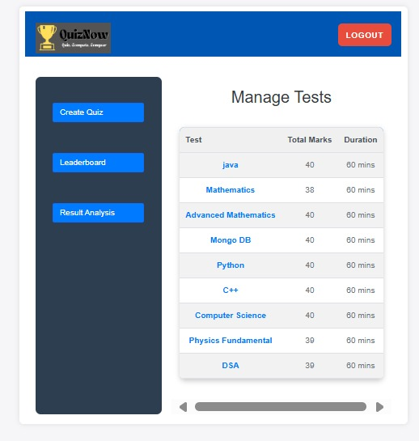

**Fig 3.1** Admin dashboard

* View detailed **student performance reports**.

## **3.2 Features for Students**

* Register and log in securely

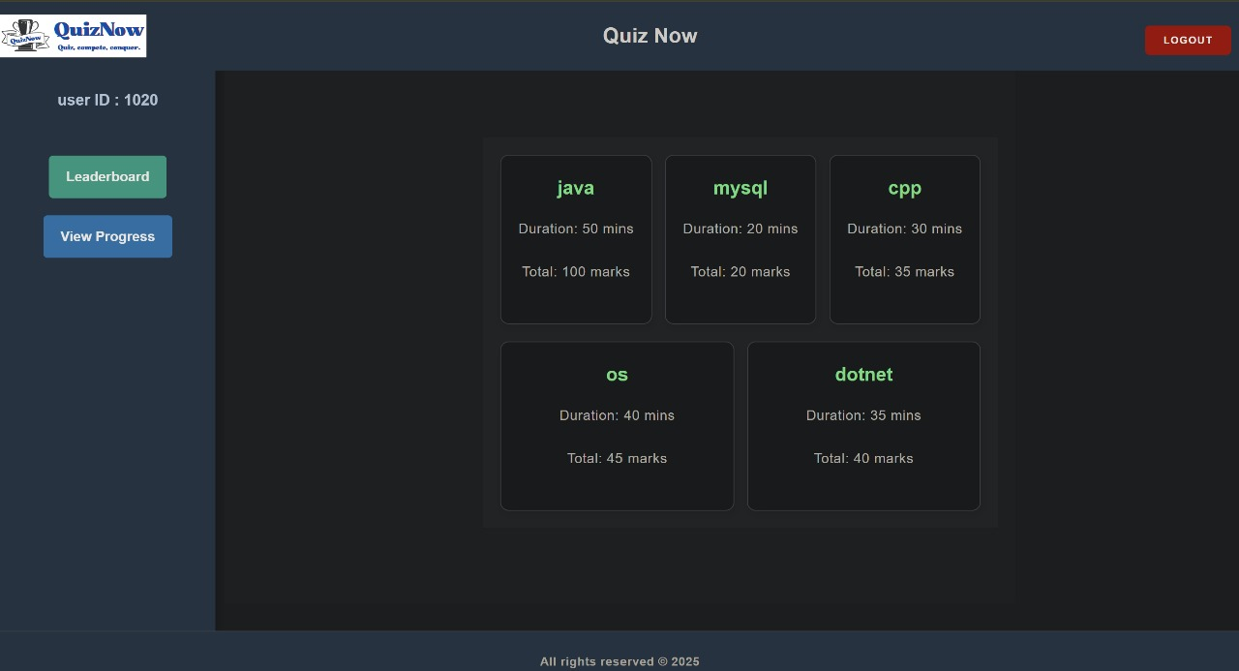

**Fig 3.2** User Dashboard

* Attempt quizzes within a **timed environment**.

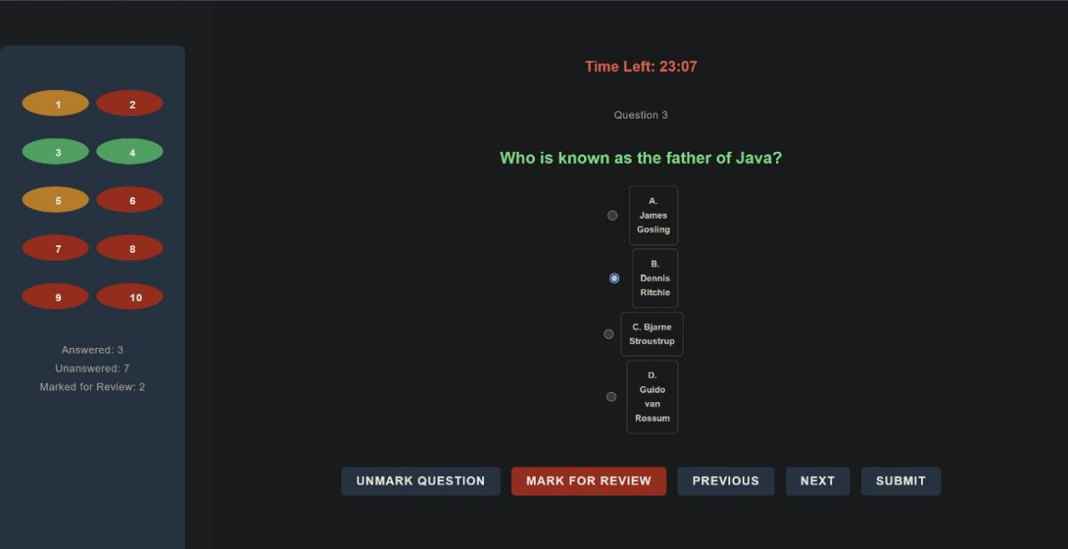

**Fig 3.3** Quiz Page

* Receive **instant feedback and scores**.

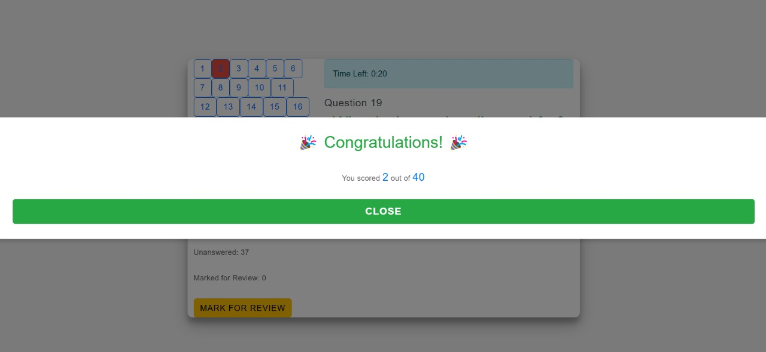

**Fig 3.4** Scoreboard

* Access a **leaderboard** displaying top performers.

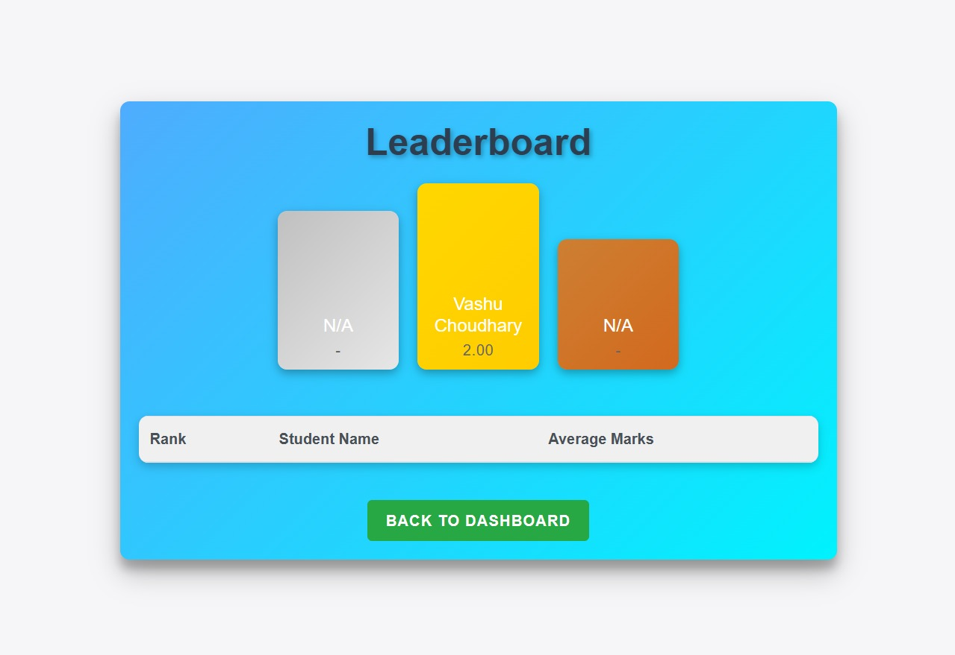

**Fig 3.5** Leader Board

**Chapter 4**

## **SYSTEM ARCHITECTURE**

The system follows a **three-tier architecture**:

### ****1. Frontend (React.js) - User Interface Layer****

The **frontend** is built using **React.js**, providing an interactive and seamless **User Interface (UI)** for both **students** and **admins**. It communicates with the backend via **REST APIs** and ensures a smooth user experience.

#### ****Key Features of the Frontend:****

**User Authentication:** Login/Signup for students and admins.  
 **Quiz Interface:**

* Students can view available quizzes categorized by subjects.
* A countdown timer ensures quizzes are completed within the given duration.
* Auto-submit functionality when time runs out.

**Admin Panel:**

* Admins can **upload quizzes** using CSV files categorized by subjects.
* View student scores per subject.
* Manage users and quizzes.  
   **Leaderboard:** Displays rankings based on scores across subjects.  
   **Security Features:** Prevents **multiple tabs** from being opened and **auto-submits** if detected.

### ****Backend (Spring Boot & REST APIs) - Business Logic Layer****

The **backend** is implemented using **Spring Boot**, which provides a robust and scalable architecture for handling:

**Core Responsibilities:**

**User Management:** Handles authentication and authorization for students and admins.  
 **Quiz Management:**

* Admins can upload quizzes using CSV files.
* Manages question retrieval for students.  
  🔹 **Score Calculation & Storage:**
* Auto-evaluates answers after submission.
* Stores scores in the database.

**Real-time Monitoring:**

* Auto-submission of quizzes when the timer expires.
* Prevents multiple tab switching during an active quiz session.

**REST API Development:**

* The backend exposes **RESTful APIs** for frontend communication.

**API Endpoints:**

* POST /quiznow/login – Login for users
* POST / quiznow /tests/upload – Upload quizzes via CSV
* GET / quiznow /tests/{topic} – Fetch quizzes by subject
* POST / quiznow /testmarks/submit – Submit answers and calculate scores
* GET / quiznow /testmarks/leaderboard – Retrieve student rankings

### ****3. Database (MySQL) - Data Storage Layer****

The **MySQL database** stores all the essential data, ensuring **data consistency, security, and performance**.

#### ****Database Tables & Schema:****

**Users Table:** Stores student and admin credentials  
 **Quizzes Table:** Stores quiz questions, options, correct answers, and subjects  
 **Student Scores Table:** Records scores of students for each quiz  
 **Leaderboard Table:** Stores rankings of students across subjects

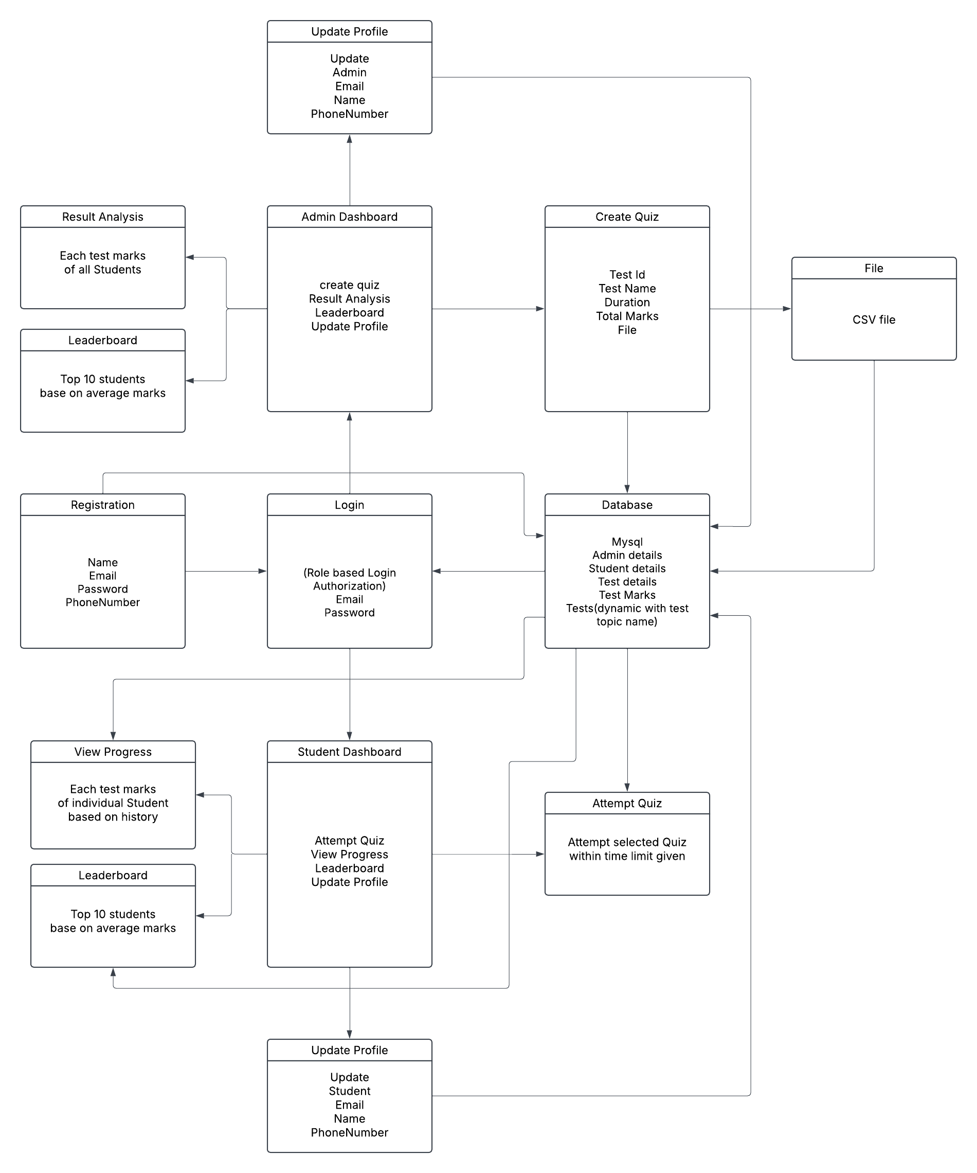

**Fig 4.1** System Architecture Diagram.

**Chapter 5**

## **FUNCTIONAL REQUIREMENT**

## **5.1 User Management**

The **User Management** module handles authorization, and user role management.

### ****Features:****

**Secure User Registration & Login:**

* Users (Students & Admins) can **register** and **log in** securely.
* Passwords are **hashed** using **BCrypt** for security.
* JWT (JSON Web Token) authentication is used for secure API access.

**Role-Based Access Control (RBAC):**

* **Students:** Can attempt quizzes and view scores.
* **Admins:** Can **manage users**, upload quizzes, and view reports.

**Admin Controls:**

* Admins can **view, edit, and delete** user accounts.
* Can **reset passwords** if required.

**Example API Endpoints:**

* POST /quiznow/register – User registration
* POST /quiznow/login – User login
* GET /quiznow/testmarks/resultanalysis– Admin retrieves result analysis

## **5.2 Quiz Management**

The **Quiz Management** module allows **admins to create, manage, and organize quizzes**.

### ****Features:****

**CSV Upload for Bulk Quiz Addition:**

* Admins can **upload quizzes in bulk** using CSV files.
* The system **validates** the file format before storing questions.

**Subject-Wise Quiz Storage:**

* Quizzes are categorized **by subject** in the database.
* Each question has **multiple-choice options** and one **correct answer**.

**CRUD Operations for Admins:**

* **Create:** Add new quizzes manually or via CSV.
* **Read:** View existing quizzes by subject.

**Question Randomization:**

* The system **randomizes** questions each time a quiz is attempted.
* Prevents memorization-based cheating.

**Example API Endpoints:**

* POST /quiznow/tests/upload – Upload quiz via CSV
* GET /quiznow/tests/{subject} – Retrieve quizzes by subject

## **5.3 Quiz Attempt and Scoring**

This module allows students to **attempt quizzes within a time limit** and ensures **automated scoring**.

### ****Features:****

**Timed Quiz Attempts:**

* Each quiz has a **fixed time limit**.
* The **countdown timer** ensures fair play.

**Auto-Submission on Timeout:**

* If a student **fails to submit before time expires**, the system **auto-submits** the quiz.
* Ensures that late responses are not accepted.

**Auto-Evaluation & Scoring:**

* The backend compares submitted answers with the **correct answers stored in the database**.
* The **final score is calculated automatically**.

**Instant Feedback & Results:**

* After submission, students can **view their scores**.
* Admins can view **detailed responses** for each student.

**Example API Endpoints:**

* POST /quiznow/testmarks/submit – Submit answers for evaluation

## **5.4 Reports & Leaderboard**

This module provides **performance insights** for both students and admins.

### ****Features:****

**Admin Reports:**

* Admins can view **student scores per subject**.
* Can generate **detailed reports** with **quiz performance analysis**.

**Leaderboard Ranking:**

* Displays **top-performing students**.
* Ranks students **based on scores across subjects**.

**Filtering & Sorting:**

* View **subject-wise leaderboards**.
* Filter students based on **highest scores, attempts, and rankings**.

**Student Performance History:**

* Students can **track their past scores**.
* Helps in self-assessment and improvement.

**Example API Endpoints:**

* GET /quiznow/admin/resultanalysis – View student scores for a subject
* GET /quiznow/leaderboard – Fetch top-ranking students
* GET /quiznow/student/viewprogress/{id} – Fetch performance history of a student

**Chapter 6**

## **DATABASE DESIGN**

| **Table Name** | **Description** |
| --- | --- |
| **admin_details** | Stores administrator details, including login credentials and role-based access. |
| **student_details** | Contains student information, including registration details and login credentials |
| **test_details** | Stores quiz metadata such as subject, duration, and test availability. |
| **test_marks** | Tracks student quiz attempts, scores, and performance. |
| **questions** | Stores quiz questions dynamically, supporting multiple subjects and difficulty levels. |

**Chapter 7**

## **TECHNOLOGY STACK**

* **Frontend:** React.js, HTML, CSS, JavaScript
* **Backend:** Spring Boot, REST APIs
* **Database:** MySQL

**Chapter 8**

## **IMPLEMENTATION DETAILS**

**Admin Uploads Quizzes via CSV:**

* Admins can bulk upload quiz questions using **CSV files**.
* The system **parses and validates** the CSV before storing questions in **MySQL**.
* Questions are categorized by **subject and difficulty level**.

**Students Take Quizzes & Answer Validation:**

* Students **select a quiz** and attempt it within a **time limit**.
* The system **validates answers** in real time against the stored correct answers.
* If the timer expires, the quiz is **auto-submitted**.

**Real-Time Score Result analysis , View Progress & Leaderboard Updates:**

* **Instant Score Calculation:** Automatically evaluates student responses and updates scores in real time.
* **Detailed Result Analysis:** Displays correct vs. incorrect answers, percentage scores, and subject-wise performance insights.
* **Student Progress Tracking:** Provides a personalized dashboard with past quiz attempts, best scores, and performance trends.
* **Graphical Insights & Comparisons:** Uses progress charts to highlight strengths, weaknesses, and peer comparisons.
* **Dynamic Leaderboard Updates:** Ranks students based on total scores across subjects, updating in real time.

**Efficient Data Handling with MySQL:**

* **MySQL** ensures **structured storage** of users, quizzes, and scores.
* Optimized **queries retrieve test details, student scores, and rankings** quickly.
* Data consistency is maintained using **foreign keys and indexes** for fast lookups.

**Chapter 9**

## **TESTING & SECURITY CONSIDERATION**

* **Unit Testing** for API endpoints.
* **Performance Testing** for leaderboard calculations.
* **Security Measures:**
  + Passwords stored with **encryption**.
  + Secure **role-based access control (RBAC)**.

**Chapter 10**

## **Conclusion & Future Enhancement**

#### ****10.1 Summary****

The **Web-Based Quiz Platform** offers a seamless, efficient, and secure environment for conducting online quizzes. It ensures **real-time scoring, dynamic leaderboard updates, and comprehensive student progress tracking**. The platform enhances **admin control**, automates **quiz management**, and maintains **data integrity with MySQL**.

#### ****10.2 Future Enhancements****

**AI-Based Question Recommendations:**

* Implement **machine learning algorithms** to suggest personalized quiz questions based on student performance trends.

**Real-Time Cheating Detection:**

* Use **AI-based proctoring** to monitor user behavior.
* Detect **tab switching, multiple logins, and unusual activity**.

**Multi-Language Support:**

* Enable quizzes in **multiple languages** to enhance accessibility.
* Implement **real-time translation** for global reach.